We will be learning:
In Science, we will be completing our unit on ‘Living Things and their habitats’. We will be sorting and classifying animals and micro-organisms. We will also study the work of the famous scientist - Carl Linnaeus.
In History and Geography, we will discover facts about the Mayan civilisation and explain who the Mayan people were and when and where in the world they lived. We will study the different Mayan Gods and find out about their number and writing systems.
In Art, we will be combining mixed media and printing to produce ‘KING KONG’ pieces of art. We will work to combine textiles, materials and collage. The children will be inspired by the illustrations of Anthony Browne.
In Music, we will be studying a glockenspiel unit, learning how to play a musical instrument using musical notation. The children will learn about duration, tempo, melody and pitch.
In PE, the children will be enjoying swimming lessons this term. We will improve our stroke, stamina and endurance. We will also be developing our skills in football with Mrs Tyler. The children will improve their passing, dribbling, shooting and ball control.
In RE, we will be learning about Humanist views, different Humanist thinkers, their beliefs and Humanist symbols. Year 5 will take part in their statutory RSE lessons this term.
In computing, we will be learning about ‘Computer Systems and Networks’. We will learn about the importance of internet addresses and recognise how data is transferred across the internet. We will study how sharing information online can help people to work together. We will also continually focus on the importance of online safety.
In French, we will be learning about money and shopping. We will be using number words and learning to ask how much items cost. We will look at French food words and have conversations in a role-play market.

Key English skills for your child:
To make predictions about a text.
To ask open questions.
To understand the use of relative clauses.
To use effective expanded noun phrases for description.
To use similes and metaphors in poetry.
To understand and study the structure of a dilemma narrative.
To compare character roles and traits within a story.
To write comparative character descriptions.
To use paragraph indicators to structure independent writing.
To use text illustrations to inspire vocabulary and language for writing.
To write a monster description.
To understand opposing views, arguments and opinions in a text.
To write a balanced argument.

Eagle Class - Overview
AUTUMN TERM 1 - 2025

Our core story is:
‘KING KONG’ by Anthony Browne
Please do not read this at home with your child until the end of the half term so your child can enjoy hearing the poetry collection unfold in class.

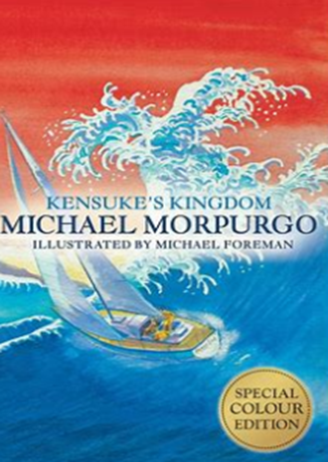
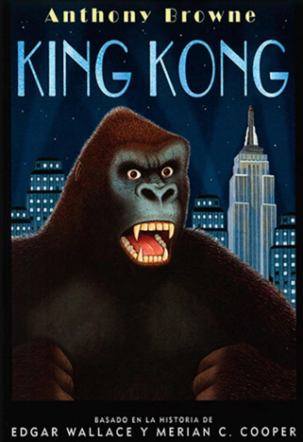
At home you could:
- Read daily at home with your child and talk about what you have read. Please use the Reading Record to record reading progress with an adult.
- Encourage your child to practise the French words, phrases and conversations they have learnt at school.
- Watch an age-appropriate film version of King Kong.
- Draw and label the main characters.
- Practise reading, saying and writing large 6-digit numbers.
- Log on to TTRS and boost your scores!
- Read other texts and stories by Anthony Browne.
- Research the discoveries and theories of Carl Linnaeus.

Please talk to Miss Knight if you have any questions.
Key Maths skills for your child:
Place Value and Four Operations:
Identify, represent and estimate numbers using different representations.
Count in multiples of 6, 7, 9. 25 and 1000.
Find 1000 more or less than a given number.
Recognise the place value of each digit.
Read, write, order and compare numbers.
Interpret negative numbers in context, count forwards and backwards with positive and negative whole numbers including through zero.
Read Roman numerals to 1000 (M) and recognise years written in Roman numerals.
Round any whole number to a required degree of accuracy.
Solve addition and subtraction multi step problems in contexts, deciding which operations and methods to use and why.
Use estimation to check answers to calculations and determine in the context of a problem, an appropriate degree of accuracy.
Recall and use multiplication and division facts for multiplication tables up to 12 × 12.
Multiply and divide numbers mentally drawing upon known facts.
Multiply and divide whole numbers by 10, 100 and 1000.

Key Knowledge
We would like you to discuss this key vocabulary with your child so that they have a greater understanding of their learning.
