We will be learning:
In Science, we will exploring Electricity and major electrical discoveries. We will be constructing and drawing circuits. We will be identifying electrical symbols and exploring and investigating electrical voltage. The children will also study famous Scientists and their electrical inventions.
In Geography, we will be asking how is planet earth formed? We will be looking at time zones, climate zones, lines of latitude and longitude, the role of the equator and the formation and location of volcanoes across the world.
In DT, we will be studying global food and broadening our understanding of where our food comes from. We will be looking at nutritional food groups and exploring simple world food recipes.
In Music, we will be continuing with our ancient Egyptian unit, learning how to use musical notation. The children will learn about duration, tempo, melody and pitch. We will also be learning to sing the songs for our Christmas musical performance.
In PE, the children will be enjoying swimming lessons this term. We will improve our stroke, stamina and endurance. We will also be developing our skills in netball with Mrs Tyler. The children will develop their passing, pivoting and shooting skills.
In RE, we will be learning about how religious beliefs can impact art and music. We will be studying art and music from different religions and finding meaning through colour, pattern and interpretation. Year 4 will take part in their statutory RSE lessons this term.
In computing, we will be learning about online safety through our ‘DIGITAL MATTTERS’ resources. We will look at online bullying, self-image online and computing lifestyles.
In French, we will be learning how to name and locate countries around the world. We will learn directional language and how to describe different climates and weather around the world.

Key English skills for your child:
- To make predictions about a text.
- To create word banks and vocabulary lists.
- To write a monologue from a character’s point of view.
- To use persuasive language to advance action and decision-making.
- To write a persuasive letter.
- To plan and organise my writing in clear paragraphs.
- To write dictated sentences including verb prefixes, modal verbs and parenthesis.
- To use illustrations as a creative stimulus for writing and artwork.
- To use drama and role-play to help understand story events, plot and motive.
- To enjoy a Shakespearean story!

Eagle Class - Overview
AUTUMN TERM 2 - 2025

Our core story is:
MACBETH by Angela McAllister
Please do not read this at home with your child until the end of the half term so your child can enjoy hearing the poetry collection unfold in class.

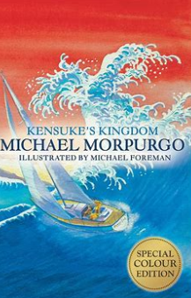
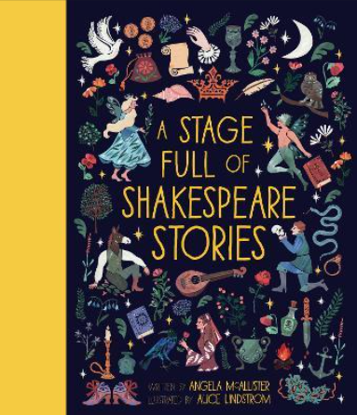

At home you could:
- Read daily at home with your child and talk about what you have read. Please focus on asking key comprehension questions about events and character actions and feelings.
- Encourage your child to practise the French words, phrases and conversations they have learnt at school.
- Practise adding and subtracting simple fractions.
- Continue to learn and practise times tables to 12 x 12.
- Research facts and information about William Shakespeare, his life and achievements.
- William Shakespeare
- Watch and read adapted versions of MACBETH.
- BBC BITESIZE – Electricity: ELECRICITY

Please talk to Miss Knight if you have any questions.
Key Maths skills for your child:
Four Operations and Fractions:
Recall and use multiplication and division facts for multiplication tables up to 12 × 12.
Multiply and divide numbers mentally drawing upon known facts.
Multiply and divide whole numbers by 10, 100 and 1000.
Know Prime Numbers to 100.
Identify common factors and common multiples.
Understand square and cube numbers.
Begin to understand and practise formal methods of long multiplication and long division.
To compare and order fractions.
To find fraction equivalents.
Add and subtract simple fractions.
Add and subtract mixed numbers.
Convert improper fractions to mixed numbers.

Key Knowledge
We would like you to discuss this key vocabulary with your child so that they have a greater understanding of their learning.
