We will be learning:
In Science, we will be continuing our learning on the Solar System, how the planets are ordered, the surface of the planets and how they orbit the sun. At the end of this half term, we will complete a mini topic on Global Warming.
In Geography, we will be studying extreme weather phenomenon such as volcano eruptions, tsunamis, hurricanes and tornadoes. We will be studying the impact on countries, communities and the environment.
In Art and DT, we will be creating a textile piece of Easter themed art for the church – this will link to our previous RE unit on Crucifixion.
In Music, we will be learning about the genre of Musical Theatre. We will study the origins of musical theatre through swing and jazz music. We will look at stage design and how music can evoke emotion and storytelling.
In our class PE lessons, we will be developing our Yoga skills, stretching, breathing for calmness and improving our flexibility.
In RE, we will be starting a new unit which studies life philosophies through the eyes of different world religions. Our first question will address how different religions view hurt and healing. Year 5 will also complete their statutory RSE lessons this half term.
In computing, we will be learning how to use multimedia graphics. We will be using Vector drawing to create images, layer objects and manipulate our designs
In French, we will be learning how to identify regular and irregular verbs in the present tense. We will apply this verb knowledge by writing our own story presentation.

Key English skills for your child:
- To understand the structural layout features of a non-fiction text.
- To understand grammatical features in detail – for example the use of semi-colons, hyphens and expanded noun phrases.
- To use illustrations as a stimulus for descriptive writing and artwork.
- To gain greater understanding of the life, behaviours and threats to wolves in the wild.
- To make predictions and gather ideas about a text.
- To use video, audio and role-play to inspire writing.
- To be able to write a documentary narrative about the pack life of the wolf.
- To plan, structure and use effective models for writing with greater independence.

Eagle Class - Overview
SPRING 2 - 2026

Our core story is:
The Ways of the Wolf - by Smriti Halls
Please do not read this at home with your child until the end of the half term so your child can enjoy hearing the story events unfold in class.

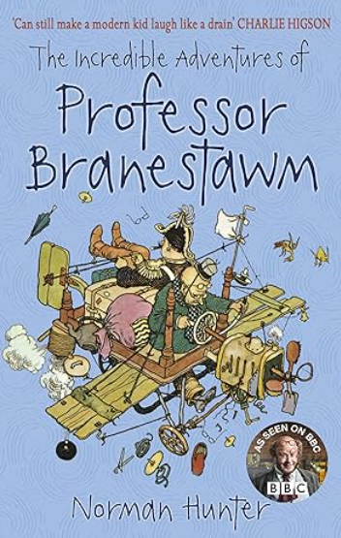
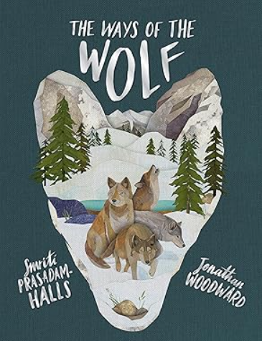
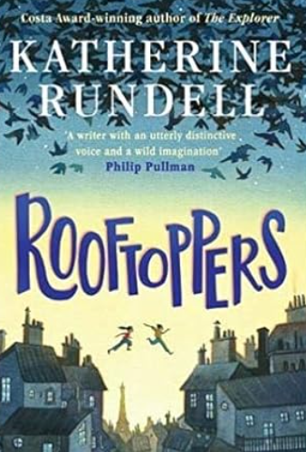
Key Maths skills for your child:
Four Operations and Fractions:
To convert metric units of measurement.
Understand imperial measures and the associated terminology.
To multiply and divide decimals within real life problem contexts.
To multiply and divide decimals by integers.
To calculate the perimeter of rectangles and polygons.
To calculate the area of rectangles and compound shapes.
To calculate the area of different triangles.
To calculate the area of parallelograms using a formula.
To form expressions inn algebra.
To create algebraic substitutions.
To solve two step equations.
To study statistics and reasoning questions through the study of line graphs, bar charts and pie diagrams.
To calculate the mean, mode and median.

Please talk to Miss Knight if you have any questions.
At home you could:
- Read daily at home with your child and talk about what you have read. Please continue to use Go Read/Boom Reader to record reading progress.
- Encourage your child to practise the French words, phrases and conversations they have learnt at school.
- Research recent volcano eruptions around the world. Map the largest volcanoes around the world.
- Listen to songs from your favourite musicals – think about how they tell the story through song.
- Look at basic algebraic questions on BBC BITESIZE. Try out some algebra questions and equations!
- KS2 Algebra - BBC Bitesize
- Research facts and information about the ready for our class writing project.

Key Knowledge
We would like you to discuss this key vocabulary with your child so that they have a greater understanding of their learning.
