Key English skills for your child:
- To make predictions and ask questions about a text.
- To understand the use of a text Glossary.
- To write an information article about the construction and voyage of the Titanic.
- To use appropriate text layout features in my own writing.
- To use persuasive language to advertise the Titanic Voyage through poster design.
- To write a diary entry in role.
- To use role-play to understand actions and emotions.
- To write a recount ordering the stages of the sinking of the Titanic.
- To write a newspaper article.
- To write a balanced argument from different viewpoints.
We will be learning:
In Science, we are studying the lifecycles of mammals, amphibians, insects and birds. We will be learning about the many different stages of life. Later in the term, we will complete mini topics on global warming and plastic pollution.
In Geography, we will be learning about climate change and how we can protect our planet and oceans. We will look at The Great Barrier Reef as a case study and complete field work on our own coastline in readiness for our trip to Southwold.
In Art, we will be completing a sketching and drawing unit. We will be focusing on work by a local artist and using our local area to create colourful landscape designs.
In PE, we will be covering a wide range of summer sports. We will be using transferable skills from netball and basketball to play Handball. Later in the term, we will focus on rounders and athletic skills for Sports day.
In RE, we will be starting a new unit on Hinduism. We will study the Hindu Four Paths to a good life, the belief in reincarnation and the power of meditation.
In computing, we will be learning how to create infinitive loops, selection and branching in programming. We will be revisiting programming using Scratch.
In French, we will be learning how name parts of the body, being able to say what is wrong, if you are feeling unwell. We will be revising the calendar, months and celebrations through the year and learning about sports and hobbies.

RSE – This term, we will begin our RSE lessons for year 5. These statutory lessons will focus on the topics of – My Body, My Rights and Responsibilities, My Beliefs, My Feelings, My Relationships and Asking for Help.

Eagle Class - Overview
SUMMER 1 - 2026

Our core story is:
TITANIC
Please do not read this at home with your child until the end of the half term so your child can enjoy hearing the story events unfold in class.

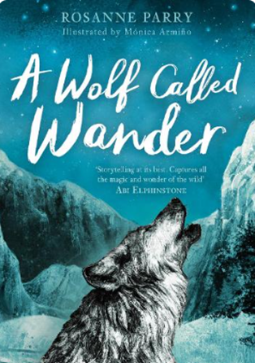
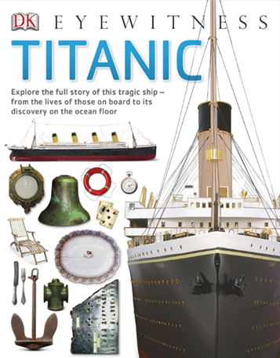
Key Maths skills for your child:
Four Operations and Fractions:

- To calculate the area of parallelograms using a formula.
- To form expressions in algebra.
- To create algebraic substitutions.
- To solve two step equations.
- To study statistics and reasoning questions through the study of line graphs, bar charts and pie diagrams.
- To calculate the mean, mode and median.
- Calculate the mean as an average.
- Draw 2-D shapes using given dimensions and angles.
- Compare and classify geometric shapes based on their properties and sizes and find unknown angles in any triangles, quadrilaterals, and regular polygons.
- Draw, reflect and translate simple shapes on the coordinate plane.

Please talk to Miss Knight if you have any questions.
At home you could:
- Read daily at home with your child and talk about what you have read. Please continue to use your child’s reading record book to record progress.
- Encourage your child to practise the French words, phrases and conversations they have learnt at school.
- Watch ‘Titanic’ the film and discuss events and settings.
- Look at basic algebraic questions on BBC BITESIZE. Try out some algebra questions and equations!
- KS2 Algebra - BBC Bitesize
- Find out about different life cycles – mammals, birds, amphibians and insects.
- Research The Great Barrier Reef and the risks and threats to this beautiful natural area.

Key Knowledge
We would like you to discuss this key vocabulary with your child so that they have a greater understanding of their learning.
